***Audience Part***

For the duration of this piece, you (the audience member) are asked to read this booklet silently to yourself. It is asked that your active attention be focused primarily on the pages here, not the performance surrounding you. Occasional special instructions enclosed in boxes may ask you to direct your attention to different things going on around youor think about different things. Although no outward actions are asked of you, such as speaking aloud or walking around, your active participation in reading this booklet and following its instructions is essential in order to fully experience the work as intended.

You and the rest of the audience will be seated among the performers and facing random directions.

Occasional written fermatas will ask you to pause reading for an approximate amount of time and allow your attention to focus more on the surrounding performance, let your mind wander, meditate, or so forth:

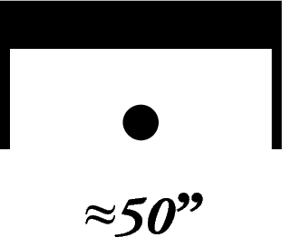

Please turn this page and begin reading once the performance begins. The performance will be over once no performer has made a deliberate sound for over a minute.